President’s Council of Hutchinson Island
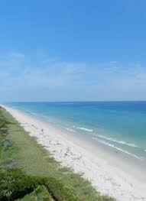

Charles Grande
President
Harvey Alligood
Vice-President
Marsha Benedict
Secretary
Don W. Stacks
Treasurer
Lou Stoddard
Director
Susan McIntyre Director
Len Amato
Director

11007 S. Ocean Dr. #6220
Jensen Beach, FL 34957
e-mail: pcofhi@gmail.com
Website: pcofhi.com/

November 11, 2021

SLC Board of County Commissioners
2300 Virginia Avenue
Ft Pierce, FL 34982

Re: Presidents Council Redistricting Preferred Scenario #3

Dear Commissioners,

After attending the Open House and viewing the scenarios, we were pleased to see that Scenario #3 is among the final 3. We appreciated the time that Leslie Olson, Mark Satterlee, and Ed Blaine took to explain the process and the technology to us.
Scenario #3 is the only one that clearly achieves the reunification objective, as we expressed in our letter to you in October. This scenario will not only reunite the two islands but, also consistent with long standing history and precedent, returns SHI into District 5. Although, Scenario #2 combines the 2 islands with common interests, it would be more disruptive since NHI has never been included in District 1.
We ask for your strong consideration of our preference and we welcome any opportunity to support your redistricting efforts.

Presidents Council Board of Directors

cc. Howard Tipton - County Administrator, Mark Satterlee – Deputy County Administrator, Leslie Olson – Planning & Development Services Director, Presidents Council Board Members

