
10000 South Ocean Drive
Jensen Beach, Florida 34957
themiramar@aol.com – themiramar@gmail.com

IMPORTANT – ATLANTIC WELLNESS CENTER [AWC]

October 28, 2019 - via e-mail

Dear Owners & Current Residents,

In case you have not heard of, or have not been keeping up with the situation, we want to give you an update on the building of the drug / alcohol rehabilitation facility on our island approximately 7 miles north of us. In May, despite the pleas of dozens of residents, county commissioners unanimously approved rezoning a 22-acre residential property to a non-residential property to accommodate the 220-bed addiction-treatment center on South Hutchinson Island. This decision was contrary of our Zoning Board’s recommendation. See attached sales flyer being distributed after zoning change was made.

Be assured that the Board of Directors are not against the building of this facility in St. Lucie County, but we are against the zoning change and the numerous issues outlined in the information below.

We would like to request you strongly consider making a donation to the legal action fund. Please send donations to and make checks payable to: Dr. Cindy Wasserman – 2024 Jacaranda Avenue – Ft. Pierce, FL 34949. For additional information or to add your name to e-mail updates you can contact her at: cwdvm1@gmail.com. She will also gladly send you documentation of funds and expenditures. If you prefer you can also send it to the Go Fund Me site. FYI, this site will deduct their fees from your donation.
https://www.gofundme.com/residents-against-the-location-of-drug-rehab-hosp

Background information -- South Hutchinson Island residents in St. Lucie County are banding together to stop the construction of a drug rehabilitation center. Two local residents, Dr. Cindy Wasserman, and Gary Cicalese, are named on a recently-filed lawsuit against the county. “Our goal is to hopefully put an end to this,” Dr. Cindy Wasserman said.

In May, despite the pleas of dozens of residents, county commissioners unanimously approved rezoning a 22-acre residential property to a non-residential property to accommodate the 220-bed addiction-treatment center on South Hutchinson Island. The Atlantic Wellness facility is an $87 million project. Wasserman says she is not against having a new treatment facility of this scale in the county. She says the location is not the right fit.

Her attorney is now tasked with reviewing the concerns Wasserman and other residents have about rezoning, safety, environmental impact, and how it fits into the comprehensive plan for the county.
“We have wetlands. Waivers were given to them which can have an effect on the land here right by the beach,” Dr. Wasserman said.

She worries about how effective the facility’s evacuation plan will be in an emergency. “There are additional strains on public services, police, fire, and ambulance getting out to a barrier island,” Wasserman said. "This is an issue with the board of commissioners voting against a great majority of their constituents.”

County leaders also noted the creation of new jobs in the county and the benefit to the tax base.
“Sometimes it’s not all about money,” Dr. Wasserman said.

A County Spokesman said the county could not offer a comment, which is standard when a county is under litigation.

Regards,
The Miramar Board of Directors
themiramar@aol.com – 772-229-1330
cc: Advantage Property Management
Miramar II Condo Association
Miramar Royale Condo Association
President’s Council
Dr. Cindy Wasserman

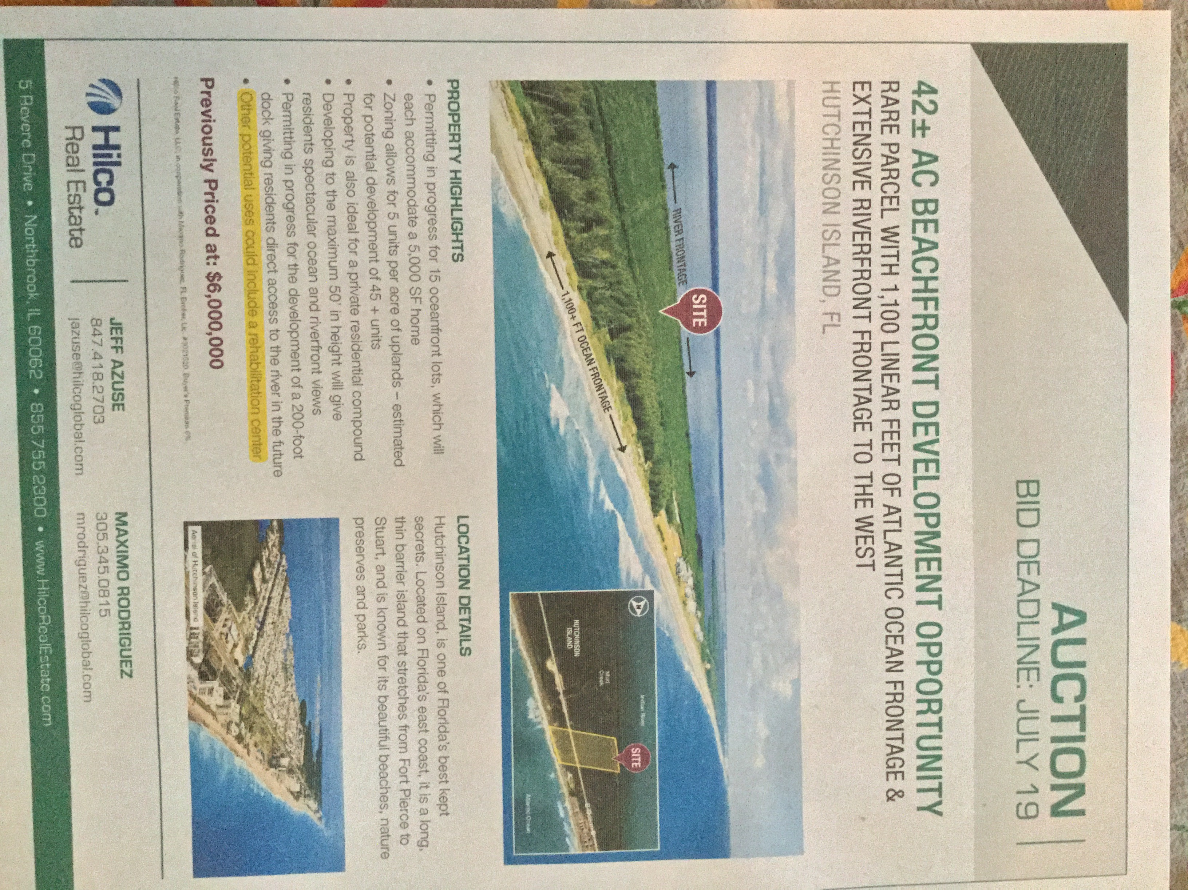

********** INFORMATION FROM CINDY WASSERMAN --August 14, 2019 **********
On June 6th, we filed our Complaint against St. Lucie County regarding their recent decision to change the zoning of the proposed Atlantic Wellness site from residential to commercial. We are asking the court for declaratory and injunctive relief.
Over the last couple of months, I have heard from many people regarding this issue. I have tried my hardest to stay engaged. I held two interviews; one with WPTV and one with Hometown News. I share our story on Facebook and discuss its merits on Next Door. I monitor our Go Fund Me site while another resident maintains it.
Although I try not to spend money on legal consultations, I do have to periodically speak with our attorney, Mr. Barkett, to clarify some issues. Yesterday, I did speak with him about two prior incidents regarding our city/county and other rehab facility proposals. The City of Fort Pierce was sued in recent years by Haven Detox of West Palm because the city denied them their request to start a rehab facility in an already existing structure on Oleander. The City agreed to settle that case for just under a million dollars in exchange for Haven Detox to not set up shop on Oleander. As per Mr. Barkett, this case is very different than what we are fighting for. In that case, the building already existed. The area was already zoned commercial. A second case involving a site in Jensen Beach never came to fruition because Jensen Beach did not even want to deal with any potential legal repercussions. From what I understand, that rehabilitation site was built.
Currently, Mr. Barkett’s group is putting the final touches on interrogatories. They will then be sent to the county for their answers. Then we wait again.
My issue has always been that the zoning change was not appropriate. This island was always meant to be residential with commercial sites being used for only small convenience stores and other amenities that would benefit the local community. Our Comprehensive Plan clearly states this. This is why I moved here. I stand by this premise. My concern was and is that once a major change like this is allowed, the next building investor will demand the same waivers and benefits that Index Investment Group was given for the proposed site…and now we see the real potential of this happening. A recent flyer was sent to me regarding a 42-acre parcel of land for sale, located adjacent to Watersong. The last bullet point is highlighted, stating that the site’s other potential uses could include a rehabilitation center. This could be just the beginning.
Although there are two named complainants on the Complaint, we represent all residents opposed to this zoning change. As a group, we have spent $11,000 thus far. Currently, we have only $4736 in the legal account. We always knew that this would not be an easy fight; things worth fighting for rarely are. We anticipate the need for an additional $9000 to get to court. If we don’t think we can raise this then we should just give up now.
There are about 200 people in my email lists. The lists are divided up, so each list has about 30 people included. This letter is going out to all of you. If we all gave $100, we would be more than fine. If you can do this please do so by either going to the Go Fund Me site or sending a check directly to me. If you have already donated, we all thank you. If you can’t afford to donate any more, that’s okay.
Please send me your comments so I once again know how to proceed. Feel free to include any questions you think would be beneficial to include in the interrogatories.
If the overwhelming majority wish to continue the fight and are willing to give more, we will continue. If most of you want to stop this fight, then we will do so. Just let me know either way. And please, continue to spread the word.
********** UPDATE FROM CINDY WASSERMAN –October 4, 2019 **********
Hope everyone is well. I’m writing this brief letter since I have been asked by several of you for an update on the case.
For now, all is quiet. I spoke with Mr. Barkett (the attorney) last week. We are still in the discovery phase. This is the fact-finding portion of the case and will take an appreciable amount of time to complete. This is why I have not corresponded with you over the past month.
A couple of you have expressed concern that we have lost momentum. No need to worry. I knew that this would be a long battle when it first started. You can be sure that I am not a sprinter but instead am ready for the long haul. I will only stop when either the attorney recommends to do so, money runs out or enough of you say it’s time. Until then, we fight.
In addition, I want everyone to know that the Diamond Sands Development HOA has joined our fight. They are making a sizable donation and stand with us. Be aware that this money will not show on the GoFundMe site as they paid it directly to the law firm.
CURRENT DONATIONS TO “GO FUND ME” IS: $14,970 -- Plus the large donation made directly to the Attorney by Diamond Sands HOA
WE REALLY NEED ANY & ALL DONATIONS WE CAN GET !
Just know that whenever I receive information about this case, I will pass it on to all of you via email. If an urgent need for anything comes up, I will also contact you.
So, for those of you who live local, keep enjoying our beautiful island. And for those of you who are here only part time, we hope to have you back soon! CINDY 10-4-2019

TC PALM -- By: Meghan McRoberts

ST. LUCIE COUNTY, Fla. — Some South Hutchinson Island residents in St. Lucie County are banding together to stop the construction of a drug rehabilitation center.
Two people, Dr. Cindy Wasserman, and Gary Cicalese, are named on a recently-filed lawsuit against the county.
“Our goal is to hopefully put an end to this,” Dr. Wasserman said.
While the names of just two residents are on the lawsuit, Wasserman said she has the support of anywhere from 50 to 70 residents behind her.
In May, despite the pleas of dozens of residents, county commissioners unanimously approved rezoning a 22-acre residential property to a non-residential property to accommodate the 220-bed addiction-treatment center on South Hutchinson Island.
The Atlantic Wellness facility is an $87 million project.
Wasserman says she is not against having a new treatment facility of this scale in the county. She says the location is not the right fit.
"I have no problem with a drug rehabilitation center. I actually have personal experience with a loved one who passed away. So, I’m well aware of what’s necessary. But, this is not an appropriate place for a 220-bed drug and alcohol rehabilitation center,” Wasserman said.
Her attorney now tasked with reviewing the concerns Wasserman and other residents have about safety, environmental impact, and how it fits into the comprehensive plan for the county.
“We have wetlands. Waivers were given to them which can have an effect on the land here right by the beach,” Dr. Wasserman said.
She worries about how effective the facility’s evacuation plan will be in an emergency.
“There are additional strains on public services, police, fire, and ambulance getting out to a barrier island,” Wasserman said. "This is an issue with the board of commissioners voting against a great majority of their constituents.”
However, the facility did receive support from other community stakeholders, including St. Lucie County Sheriff Ken Mascara.
County leaders also noted the creation of new jobs in the county and the benefit to the tax base.
“Sometimes it’s not all about money,” Wasserman said.
A County Spokesman said the county could not offer a comment, which is standard when a county is under litigation.
Dr. Wasserman has started a GoFundMe page to help cover the costs of the legal action.
Current zoning: Hutchinson Island residential
Requested zoning changes: Rezoning from residential to planned non-residential development; a conditional-use permit to allow a medical facility; and a height variance for 42-foot buildings
======================================================================
The County Commission Tuesday approved the site plan and rezoning 22 acres from residential to planned non-residential development Atlantic Wellness, an addiction-treatment center on South Hutchinson Island.
Approval was unanimous, despite more than 50% of residents answering a survey saying they opposed the facility for fear non-residential development encroaching in their neighborhood, increase in traffic and public safety concerns.
The developer still must apply for building, utilities and environmental permits from the federal, state, county and local governments, said senior planner Kori Benton.
More: St. Lucie OKs $87M 'world-class' drug, alcohol detox facility on South Hutchinson Island

