President’s Council of Hutchinson Island
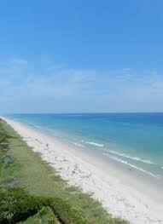

Charles Grande
President
Harvey Alligood
Vice-President
Lou Stoddard
Secretary
Don W. Stacks
Treasurer
Laura Jones
Director
Len Amato
Director
Susan McIntyre Director

11007 S. Ocean Dr. #6220
Jensen Beach, FL 34957
e-mail: pcofhi@gmail.com
Website: https://pcofhi.com/
June 3, 2020

St. Lucie County BOCC
Mr. Howard Tipton, County Manager
2300 Virginia Avenue
Fort Pierce, FL 34982

Dear Commissioners and Mr. Tipton,

We remain committed to a successful completion of the “Initial Start” with the USACE and continued engagement with you throughout.

We urge the following as soon as possible:

- The conclusion of the Project Partnership Agreement (PPA) with the USACE. And to that end, consensus on a funding plan for the remaining unfunded $8.5+/-MM balance of the So. SLC Beach project that assumes there are NO additional qualifying public access points.

- In addition, direction for the staff to diligently continue to pursue the acquisition of public access easements and qualifying of the beachfront to secure the corresponding additional federal share to reduce the local tax burden of the aforementioned funding plan. And also, at a minimum, inquire about beach access whenever otherwise engaging with any beachfront owner who controls or is adjacent to any of the strategically located access points previously identified by the County.

We hope more clarity is forthcoming soon, particularly about project funding and the PPA. We welcome the opportunity to continue to collaborate and would appreciate meeting with each of you before the June informal meeting of the BOCC. Thank you.

Yours truly,
President’s Council Board of Directors

