President’s Council of Hutchinson Island
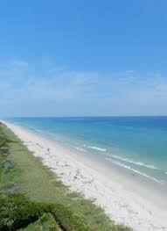
Charles Grande
President
Tom Gilson
Vice-President
Lou Stoddard
Secretary
Don W. Stacks
Treasurer
Laura Jones
Director
Harvey Alligood
Director
11007 S. Ocean Dr. #6220
Jensen Beach, FL 34957
e-mail: pcofhi@gmail.com
Website: https://pcofhi.com/

President’s Council Membership Meeting
March 17, 2020 2:00pm

Island Club – 10410 S Ocean Dr

President’s Report (Charles Grande)
- Announce future meeting dates and guest speakers.
- Introduce guest speakers – Shelley Turlock, and USACE representatives; Commissioner Frannie Hutchinson and Josh Revord, SLC representatives.

Federal South St Lucie (SLC) Beach Project
- USACE mission, mandate and projects
- Overview of the 50-year beach preservation program, including the provisions and benefits, both “scheduled” and post-hurricane nourishments
- Explanation of the rules of the program and the federal cost share parameters
- Description of differences/similarities of the implementation process for the SLC vs other federal projects
- Looking ahead discuss results of the SE Coastal Study, impacts of future technological changes, reaction to changes in rising sea levels, and possibilities for regionalization efforts

Q & A/Open Discussion (All)

Presidents Council Website pcofhi.com

