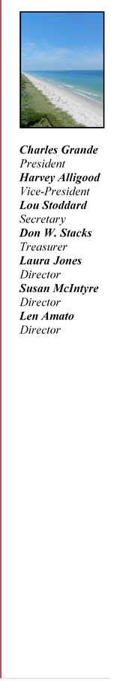
President’s Council of Hutchinson Island
11007 S. Ocean Dr. #6220
Jensen Beach, FL 34957
e-mail: pcofhi@gmail.com
Website: pcofhi.com/
March 12, 2021

Senator Wilton Simpson, President
409 The Capitol - 404 S Monroe Street
Tallahassee, FL 32399-1100

Representative Chris Sprowls, Speaker
420 The Capitol - 402 S Monroe Street
Tallahassee, FL 32399-1300

Re: State Legislation to Preempt County Home Rule

Dear Senator Simpson and Representative Sprowls,

We are writing on behalf of our 5,000 plus South Hutchinson Island residents in St. Lucie County (SLC) to respectfully request your support for the recently enacted SLC Resolution 21-026. The Resolution urges you to oppose state legislation that would preempt County home rule ability to act in the best interest of the residents of the County, unless expressly authorized by the legislation. Of particular concern to us is: SB 426 & HB 267 “State preemption of seaport regulations” and CS/SB 522 & 219 “Preempting the regulation of vacation rentals to the State”. These bills all represent examples of state standardization of regulation vs controls based on local needs. The Ft Pierce Port, with its small size and eco-sensitive environment on the Indian River, has very different needs and requirements than the other larger ports in Florida. The Master Plan for the Port is a roadmap to achieve a diverse working waterfront, aligned with the goals of expanding economic and social benefit to the citizens and businesses in SLC and along the Treasure Coast. Changes in direction on appropriate commerce in the Port, for example, would alter the short and long-term plans for the entire area.

Please consider our concerns and request for support of SLC Resolution 21-026. We appreciate your interest and welcome any opportunity for further dialogue.

Sincerely,

Charles Grande
President’s Council of Hutchinson Island Board President

cc. Senator Gayle Harrell
Representative Dana Trabulsy
St Lucie County Board of Commissioners
Presidents Council Board of Directors

