President’s Council of Hutchinson Island
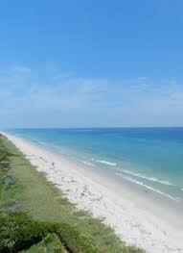

Charles Grande
President
Harvey Alligood
Vice-President
Lou Stoddard
Secretary
Don W. Stacks
Treasurer
Marsha Benedict
Director
Susan McIntyre Director
Len Amato
Director

11007 S. Ocean Dr. #6220
Jensen Beach, FL 34957
e-mail: pcofhi@gmail.com
Website: pcofhi.com/

Commissioner Cathy Townsend
St Lucie County Commissioner
2300 Virginia Ave
Fort Pierce, FL 34982

Dear Commissioner Townsend,

Presidents Council wishes to extend our thanks to you for your openness, honesty, and ongoing support. Your willingness to attend the May member meeting and speak on a wide range of topics and listen to our specific concerns was appreciated by all. The follow up meeting with Charles Grande, Harvey Alligood, and Len Amato further demonstrated your interest in engaging with us and providing support. Thank you for your time and efforts on our behalf.

Your support for county wide sourced funding for the “local share” of the Federal Beach Renourishment Project is a welcome sign and greatly appreciated.

As we discussed, we welcome and need your support to reunite SHI with NHI into District 5 through the redistricting process. With the number of common issues/concerns, including island safety and beach preservation, and, your understanding and interest in them, both Islands will benefit from this change and therefore, the County overall.

We look forward to working with you and supporting your efforts.

Presidents Council Board of Directors

